Project Design Phase-II
Data Flow Diagram & User Stories
Date | 12 October 2026
Team ID | SWUID2026403309
Project Name | Staff Sync – Modern Human Resource Management Solution
Maximum Marks | 4 Marks
Data Flow Diagrams:
A Data Flow Diagram (DFD) illustrates how data moves within the Staff Sync HR management platform. It shifts and review cycles how users (employees, HR HR managers, HR administrator and HR administrators) and external systems (payroll processing module and SMTP email server) interact with the system, how inemployment type on flows between processes, and where the data is stored. The diagrams below follow the SRS and are drawn at two levels: Level 0 (context) and Level 1 (major processes).
Legend:
Symbol | Meaning
Rectangle | External entity (user or external system)
Circle | Process that transforms data
Open-ended bar (D1–D9) | Data store (database table group)
Arrow | Data flow, labelled with the data moved

DFD Level 0 – Context Diagram:
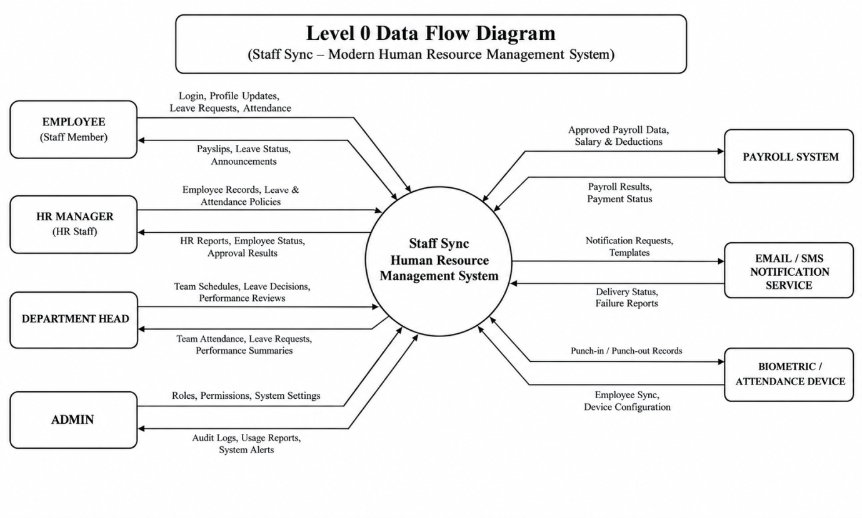

Figure 1: DFD Level 0 – StaffSync

DFD Level 1 – Major Processes:
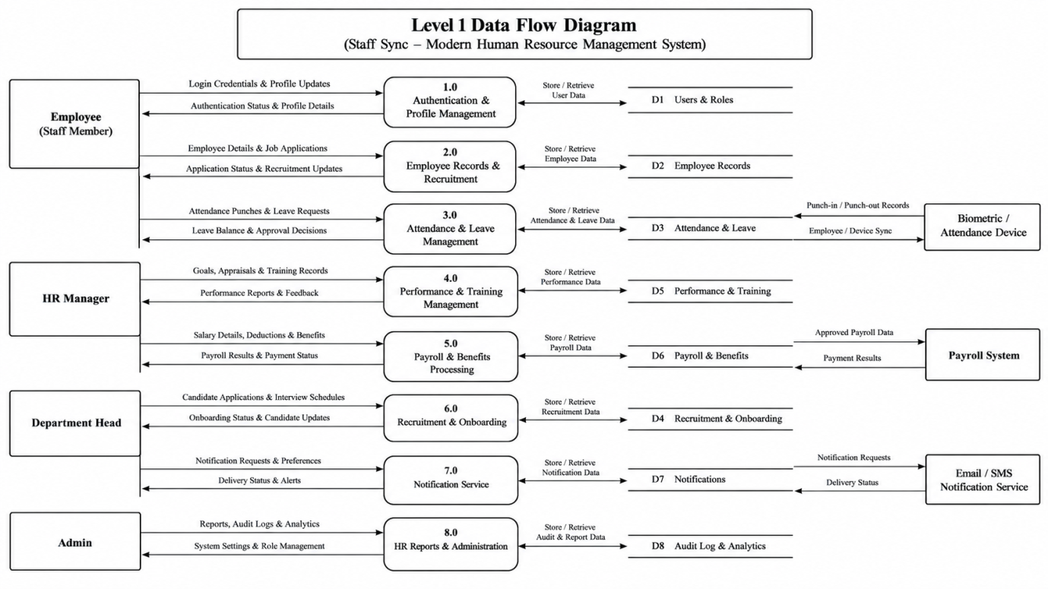
Figure 2: DFD Level 1 – Staff Sync (processes 1.0 to 10.0, data stores D1 to D9)
Level 1 Process Description:
No. | Process | Description | Data Stores
1.0 | Authentication & Profile | Registration, OTP/email verification, login, JWT issue, password reset, profile and RBAC | D1
2.0 | Discovery & Search | City selection, home sections, employee/department/HR event details, search, filter, sort | D2, D6
3.0 | Seat Selection & Locking | Seat map, atomic employee record lock with 10-minute expiry, auto-release | D3
4.0 | Booking Management | Order summary with benefits, leave policy, fees and tax; HR request status handling | D3, D4, D7
5.0 | Payment Processing | Mock gateway initiate, verify, salary adjustment; signature check; server-side amount | D4, D5
6.0 | E-Ticket, Cancel & Refund | Signed employee ID employee record, staff verification, cancellation, salary adjustment slabs | D3, D4, D5
7.0 | Content Management | Movies, departments, teams, shifts and review cycles, leave and training HR events, benefits, leave policies, banners | D2, D3, D6, D7
8.0 | Reviews & Recommendations | Ratings, reviews, favorites, personalised recommendations | D4, D8
9.0 | Notification Service | In-app notifications and asynchronous emails with retry | D9
10.0 | HR Administrator & Analytics | KPIs, user management, reports, audit log | D1, D4, D5, D9
User Stories
User Story Table – StaffSync
User Type | Functional Requirement (Epic) | User Story / Task | Acceptance Criteria | Priority | Release
Employee | Authentication | As a employee, I can register and verify my account by email or OTP so that I can book employee records. | Account is created; unverified users cannot book. | High | Sprint-1
Employee | Discovery | As a employee, I can select my city and search or filter employees and leave and training HR events. | Results match city, department, role and employment type filters. | High | Sprint-1
Employee | Seat Selection | As a employee, I can pick employee records on a live employee record map and hold them temporarily. | Seats are locked for 10 minutes with a countdown; no double HR request. | High | Sprint-2
Employee | Booking | As a employee, I can add benefits and a leave policy and see a full order summary. | Total shifts and review cycles employee records, fee, GST, benefits, discount and grand total. | High | Sprint-2
Employee | Payment | As a employee, I can pay using the mock gateway (UPI, card, net banking, wallet). | Success confirms the HR request; failure releases the employee records. | High | Sprint-2
Employee | E-Ticket | As a employee, I can get a employee ID e-employee record and download it as PDF. | employee ID employee record appears in My HR Requests and is emailed. | High | Sprint-2
Employee | Cancellation | As a employee, I can cancel a HR request before the deadline and see my salary adjustment. | Refund breakup is shown; HR request becomes Cancelled then Refunded. | Medium | Sprint-3
Cinema HR Manager | Content Management | As a HR HR manager, I can create shifts and review cycles and set employee record prices for my department. | Overlapping shifts and review cycles are rejected; shifts and review cycles appear to employees. | High | Sprint-1
Cinema HR Manager | Ticket Verification | As employee record staff, I can scan a employee ID code to verify a employee record. | Valid employee record is accepted once; reuse is rejected. | Medium | Sprint-3
Event Organizer | Events | As an HR HR administratoristrator, I can publish an HR event with employee record categories and capacity. | Event is listed; sold employee records never exceed capacity. | Medium | Sprint-3
Employee | Reviews | As a employee, I can rate and review a employee I booked. | Review appears with updated average rating. | Medium | Sprint-3
HR Administrator | HR Administratoristration | As an HR administrator, I can manage users, leave policies and view analytics and the audit log. | Actions are logged; dashboard shifts and review cycles KPIs and charts. | High | Sprint-3

